

Receive your images and radiology report
securely in digital form


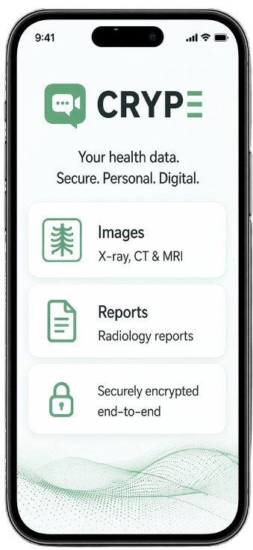


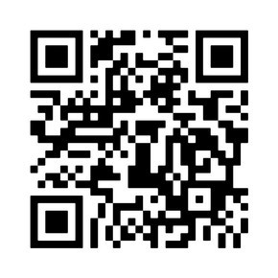
ID:
Contact:
Patient DataHub Asterland
1234 5678 1234 5678
👉 Enter in the CRYPE search field at the top

Or
- X-ray, CT & MRI images
- Radiology reports
- Available immediately after release

Send previous reports or images?
Alternatively: Also available on desktop www.crype.eu
Many of our patients register directly here in the waiting area.
No CD. No complicated download portal.
Securely and personally provided to you.
📲 Register now - free of charge
1. Scan the QR code and install the app
2. Create your CRYPE account (approx. 2 minutes)
Directly on your smartphone. Secure and confidential

